

East West University

Department of Computer Science & Engineering

**Course Title:** Database System

**Course Code:** CSE301  
**Experiment No:** 09

**Semester:** Fall, 2015

**Section:** 01

**Submitted By:**

S. M. Amirul Islam

ID: 2013-1-60-048

**Introduction:**

In SQL, server can be defined as the set of logically group of sql statement which is grouped to perform a specific task. The main benefit of using a Stored Procedure is that it increases the performance of the database by reducing the amount of information sent to the database server. The other benefits of using the Stored Procedure is that compilation step is required only once when it is created, it helps in re-usability of the sql code and is helpful in enhancing the security. In this experiment, we will try to learn about Stored Procedure in database.

**Lab Examples:**

Query of all Tables with Outputs:

**Customer:**

create table Customer

(

customer_id int ,

name varchar(20),

address varchar(30),

primary key(customer_id)

)

create procedure Customer_get (@a int,@b varchar(50),@c varchar(50))

as

begin

insert into Customer values (@a,@b,@c)

end

exec Customer_get 105,'Asif','Dhaka'

exec Customer_get 925,'Ana','Sylhet'

exec Customer_get 820,'Dona','Raj'

exec Customer_get 207,'Alif','Bogra'

select*from Customer

**Output:**

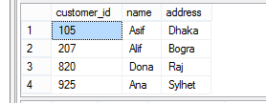

**Account:**

create table Account

(

acc_no int not null,

balance int,

branch_name varchar(50),

primary key(acc_no)

)

create procedure Account_get (@a int,@b varchar(50),@c varchar(50))

as

begin

insert into Account values (@a,@b,@c)

end

exec Account_get 101,20000,'BD'

exec Account_get 103,50000,'CD'

exec Account_get 206,70000,'AD'

select * from Account

**Output:**

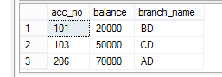

**Loan:**

create table Loan

(

loan_no int not null,

amount int not null,

branch_name varchar(50),

primary key(loan_no)

)

create procedure loan_get (@loan_no int,@amount int,@branch_name varchar(50))

as

begin

insert into loan values (@loan_no,@amount,@branch_name)

end

exec loan_get 245,10000,'AB'

exec loan_get 310,15000,'BD'

exec loan_get 350,8000,'BD'

exec loan_get 450,7000,'CD'

select*from Loan

**Output:**

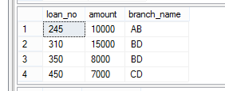

**Q1. Write a procedure to get the amount by giving loan no.**

Ans:

create procedure get_amount (@loan1_no int)

as

begin

select amount from Loan where loan_no =@loan1_no

end

exec get_amount 245

**Output:**

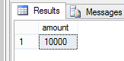

**Q2. Write a procedure to get the balance of a branch.**

Ans:

create procedure get_balance (@branch1_name varchar (20))

as

begin

select balance from Account where branch_name=@branch1_name

end

exec get_balance 'CD'

**Output:**

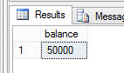

**Q3. Write a procedure to get customer name from a customer id.**

Ans:

create procedure get_name (@customer_id1 int)

as

begin

select name from Customer where customer_id=@customer_id1

end

exec get_name 207

**Output:**

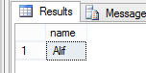

**Q4. Write a procedure to get customer id from a customer name.**

Ans:

create procedure get_customer_id (@name1 varchar(20))

as

begin

select customer_id from Customer where name=@name1

end

exec get_customer_id 'Asif'

**Output:**

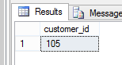

**Q5. Write a procedure to get customer name/id from a customer address.**

Ans:

create procedure get_customer_id1 (@address1 varchar(20))

as

begin

select customer_id from Customer where address=@address1

end

exec get_customer_id1 'Dhaka'

**Output:**

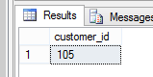

**Q6. Write a procedure to insert value in customer table.**

Ans:

create procedure Customer_add (@a int,@b varchar(50),@c varchar(50))

as

begin

insert into Customer values (@a,@b,@c)

end

exec Customer_add 1000,'Aslam','Comilla'

**Output:**

**Before Insertion:**



**After Insertion:**

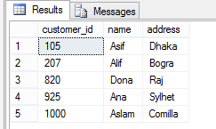

**Q7. Write a procedure to update the amount by twice for given loan no.**

Ans:

create procedure uxyz (@xloan_no int)

as

begin

update loan set amount=amount*2 where loan_no=@xloan_no

end

exec uxyz 245

**Output:**

**Before Update:**



After Update:

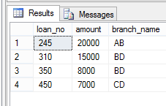

**Lab Report Problems:**

**Q1. Write a procedure to insert the values in the dept table and instructor table.**

Ans:

**Department:**

create table dept(

deptid int not null,

deptname varchar(20),

primary key(deptid)

)

create procedure dept_add (@deptid int,@deptname varchar(20))

as

begin

insert into dept values (@deptid,@deptname)

end

exec dept_add 60,'CSE'

exec dept_add 50,'ECE'

exec dept_add 30,'Math'

exec dept_add 20,'ENG'

exec dept_add 10,'BBA'

select*from dept

Output:

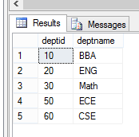

**Instructor:**

create table instructor(

insid int not null,

insname varchar(20),

deptid int not null,

salary int,

primary key(insid)

)

create procedure ins_add (@insid int,@insname varchar(20),@salary int,@deptid int)

as

begin

insert into instructor values (@insid,@insname,@salary,@deptid)

end

exec ins_add 101,'asif',12000,60

exec ins_add 123,'ana',15000,60

exec ins_add 125,'asif',16000,30

exec ins_add 130,'asif',8000,20

exec ins_add 135,'bob',12000,10

exec ins_add 150,'asif',12000,50

select*from instructor

Output:

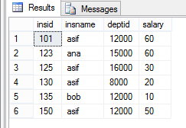

**Q2. Write a function to take the id of two employees and compare their salaries and return the id of the employee whose salary is highest among them.**

Ans:

create function highestSalary (@ins1 int,@ins2 int)

returns int

as

begin

declare @id int;

declare @salary1 int;

declare @salary2 int;

select @salary1=salary from instructor where insid=@ins1

select @salary2=salary from instructor where insid=@ins2

if @salary1>@salary2

set @id=@ins1

else

set @id=@ins2

return @id

end

Output:

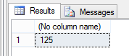

**Q3. If there is more than 3 employees named asif then print that there are more than three asif in the university. Else print that there are three or less asif in the university**

Ans:

if(select count (customer_id) from Customer where name like 'Asif')>3

begin

print 'there are more than three asif in our university.'

end

else

begin

print 'there are three or less asif in our university.';

end

**Output:**

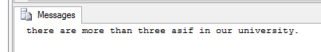

**Q4. Declare a variable and set a number in that. If the number is more than 100, then print that the number is large, if the number is less than 10 then print that the number is small. If the number is in the range 10-100 then print that the number is medium.**

Ans:

declare @number int;

set @number=50;

if @number>100

print 'the number is large.';

else

begin

if @number<10

print 'the number is small.';

else

print 'the number is medium.';

end

**Output:**

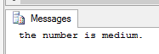

**Conclusion:**

After doing this experiment, we came to know how to write Set Operation commands and have seen the outputs after they are executed.